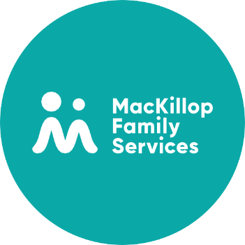

WA-F-133 Indigenous Healing Service Self-Referral Form

Please email all referrals to IHS@MacKillop.org.au
OR
Bring them by the office: 2/7 Tonkin Street, South Hedland

Client Details
This referral is for: | ☐ Me ☐ My child ☐ A child in my care ☐ Someone else
My Name:
Client Name:
Cultural Background: (Please provide details)
DOB:
Gender:
Address:
If under 18: | Name of Primary Carer:
 | Relationship to Child:
 | DOB:
 | Contact phone number:
 | Email:
Is this child under the care of the Department of Communities? | Yes ☐ No ☐ (If yes, please provide details below)
 | Name of Case Manager:
 | Case Manager Contact Details:

Referral Details
Date of Referral:
Some of the worries I have for myself/this child are: (Check all that apply)
☐ Feeling worried  ☐ Physical health  ☐ Not sleeping good  ☐ Not eating good  ☐ Grog, gunja or other drugs  ☐ Trouble with the law  ☐ Gets wild or aggressive  ☐ Grief and loss  ☐ Mixed up thoughts  ☐ Not going to school  ☐ Self-harm behaviour |  | ☐ Suicidal behaviour or suicidal thoughts  ☐ Hearing voices or seeing things  ☐ Harmful, or worrying sexual behaviour  ☐ Feeling sad, or not interested in doing things  ☐ Trouble focusing and/or remembering things  ☐ Family trouble, humbug or worry  ☐ Running off to unsafe places  ☐ Homelessness  ☐ Diagnoses (e.g., Autism, FASD)  Please specify:
Other concerns:
Things that help me/this child feel happy and strong:
What are your hopes/goals for what can be achieved in counselling?
Allergies or special dietary requirements?  (IHS may sometimes provide snacks) | Yes ☐ No ☐ (If yes, please provide details below)

